BAB 2. TCP/IP Model

Tujuan
- Mahasiswa mampu melakukan identifikasi transmisi data menggunakan model TCP/IP
- Mahasiswa mampu melakukan identifikasi layer dari model TCP/IP
- Mahasiswa mampu menggunakan aplikasi untuk mengidentifikasi data dari model TCP/IP

Dasar Teori

OSI Layer
OSI adalah referensi komunikasi dari Open System Interconnection. OSI model digunakan sebagai referensi untuk membahas spesifikasi protokol. OSI model terdiri dari 7 layer seperti pada tabel 1.

Layer # | Nama | Unit Enkapsulasi | Deskripsi/Fungsi
7 | Application | Data | Mendefinisikan pelayanan (services) komunikasi pada suatu aplikasi
6 | Presentation | Data | Mendefinisikan format data
5 | Session | Data | Mendefinisikan pengontrolan komunikasi | dan | memulai, mengakhiri
4 | Transport | Segment | Mendefinisikan jenis pengiriman
3 | Network | Paket | Mendefinisikan pengiriman dari titik ke titik.
2 | Data Link | Frame | Mendefinisikan pengiriman data | cara | pengaturan
1 | Physical | bit | Mendifinisikan bentuk interface dari sebuah media transmisi
Tabel 1. OSI Layer

Dimana setiap layer memiliki fungsi dan contoh masing-masing.

TCP/IP Model
TCP/IP (singkatan dari Transmission Control Protocol/Internet Protocol), adalah gabungan dari protokol TCP dan IP sebagai sekelompok protokol yang mengatur komunikasi data dalam proses tukar-menukar data dari satu komputer ke komputer lain di dalam jaringan Internet yang akan memastikan pengiriman data sampai ke alamat yang dituju. Protokol ini tidaklah dapat berdiri sendiri, karena memang protokol ini berupa kumpulan protokol (Protocol Suite).
Arsitektur TCP/IP tidaklah berbasis OSI Layer, tetapi menggunakan model referensi DARPA. Seperti pada gambar 11., TCP/IP mengimplementasikan arsitektur berlapis yang terdiri atas empat lapis. Empat lapis ini, dapat dipetakan terhadap model OSI layer. Empat lapis ini, disebut juga DARPA Model atau DOD Model.

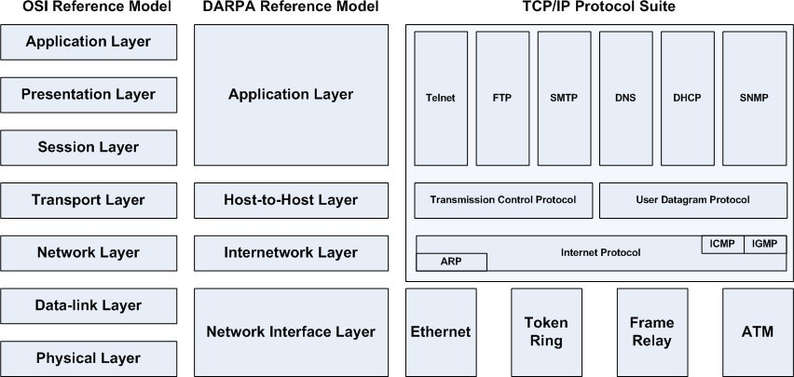
Gambar 11. OSI Layer vs TCP/IP Protocol Suite.

Pengenalan Aplikasi

Wireshark
Wireshark adalah aplikasi penganalisa paket jaringan (Network Packet Analyzer). Sebuah software penganalisa paket jaringan yang bekerja dengan cara menangkap paket jaringan dan mencoba untuk menampilkan data paket yang tertangkap dengan detail.
Wireshark bersifat open source. Contoh penggunaan wireshark:
      - Administrator jaringan menggunakan untuk melakukan penangan masalah jaringan
      - Network security engineer menggunakan untuk memeriksa keamanan jaringan
      - Developer menggunakan untuk melakukan debug pada implementasi protokol
      - Umum digunakan untuk mempelajari internal protokol jaringan

Wireshark memiliki fitur:
      - Tersedia untuk UNIX dan Windows.
      - Menangkap paket data langsung dari network interface.
      - Tampilan paket dengan informasi protokol yang sangat rinci.
      - Open dan Save data paket yang dicapture.
      - Import dan Eksport paket data dari dank e banyak program capture lainnya.
      - Menyaring paket data dengan berbagai macam kriteria.
      - Warnai layar paket berdasarkan filter.

Cara penggunaan Wireshark
Langkah-langkah menggunakan wireshark
- Klik ikon…


- Kemudian akan tampil aplikasi wireshark dengan diawali spash screen.
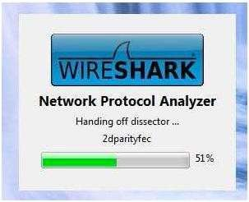

- Tampilan awal program Wireshark.
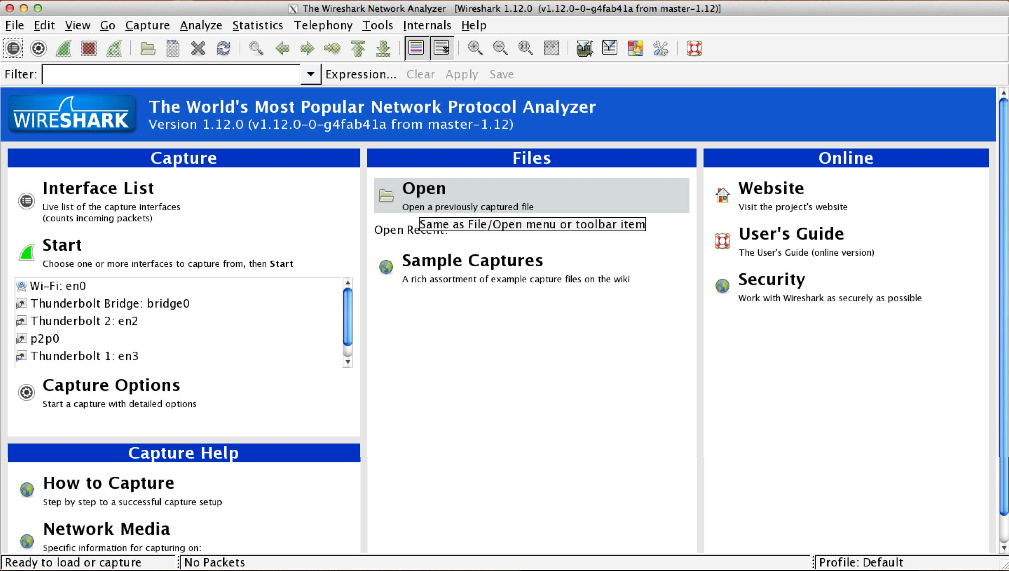
- Keterangan menu wireshark.
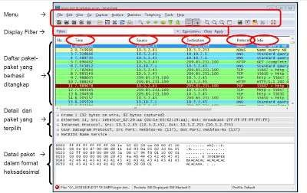

- Melakukan CAPTURE data menggunakan wireshark. Pilih menu INTERFACE.

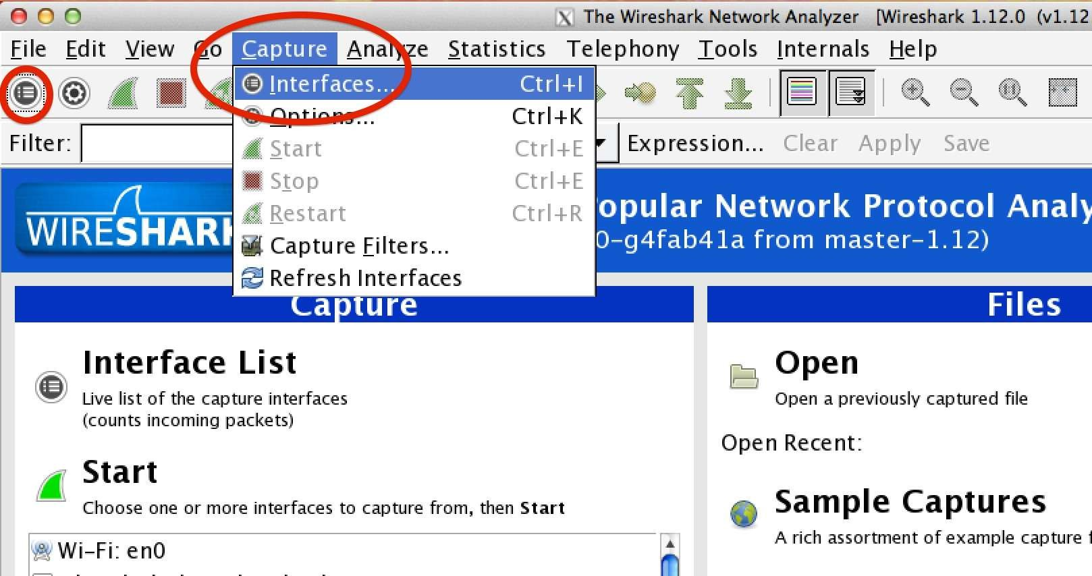

- Pilih interface yang kita gunakan, kemudian klik start.
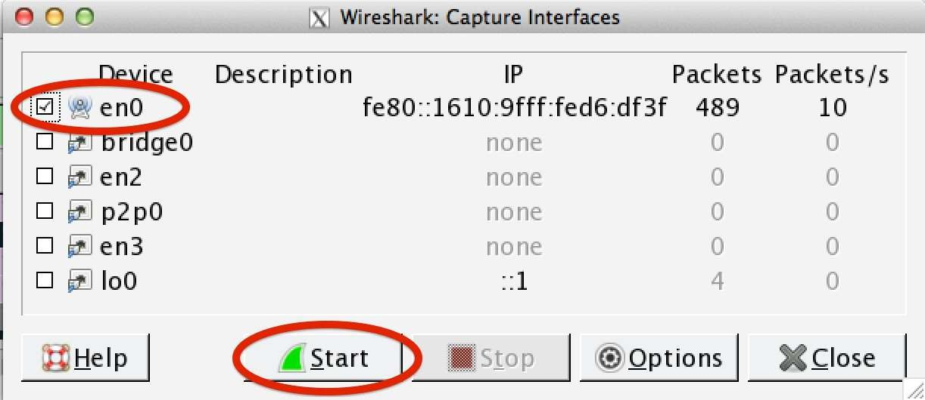
- Setelah mengaktifkan interfaces, Wireshark akan beraksi membaca semua data yang berada di jaringan.
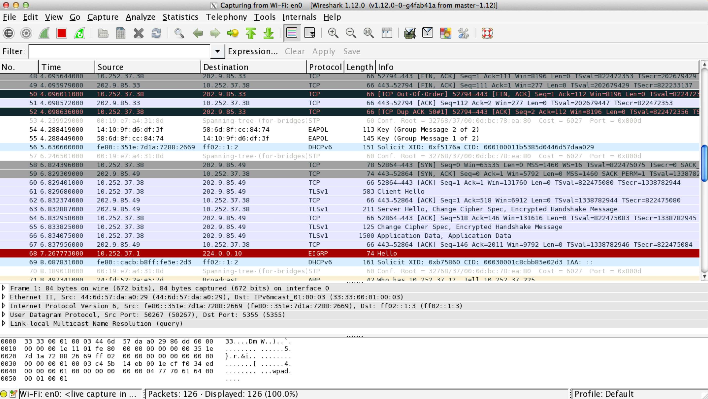
Terlihat banyak data yang dapat dicapture. Keterangan:
Source Alamat IP pengirim Destination Alamat IP tujuan
Protocol Jenis protokol yang digunakan, seperti TCP, DHCP, dll Length Panjang data yang dikirimkan
Info Informasi isi data yang dikirimkan

- Ketikkan ICMP pada filter box untuk melakukan penyaringan data yang akan ditampilkan sehingga hanya data PING yang akan ditampilkan.

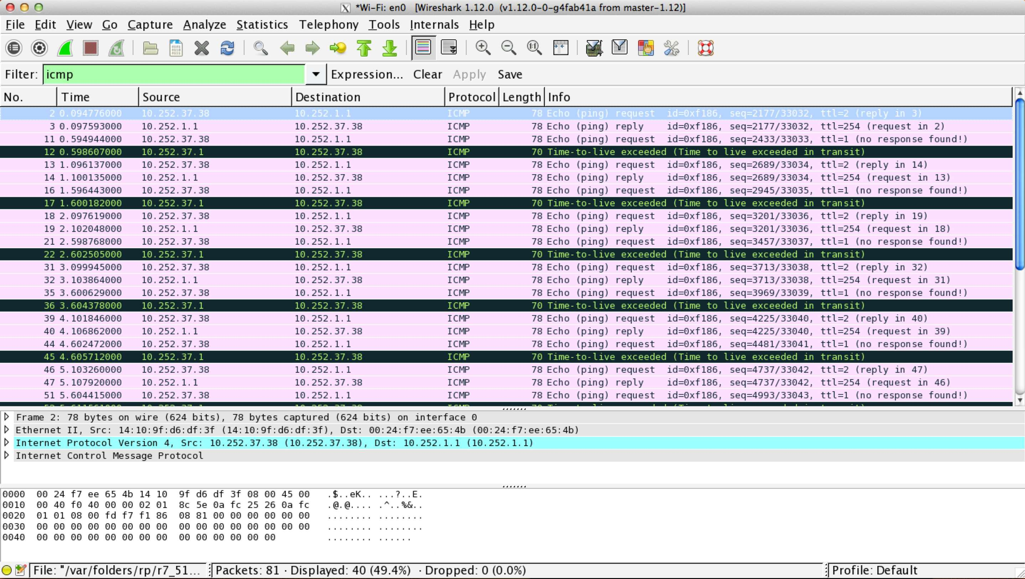
- Penjelasan data
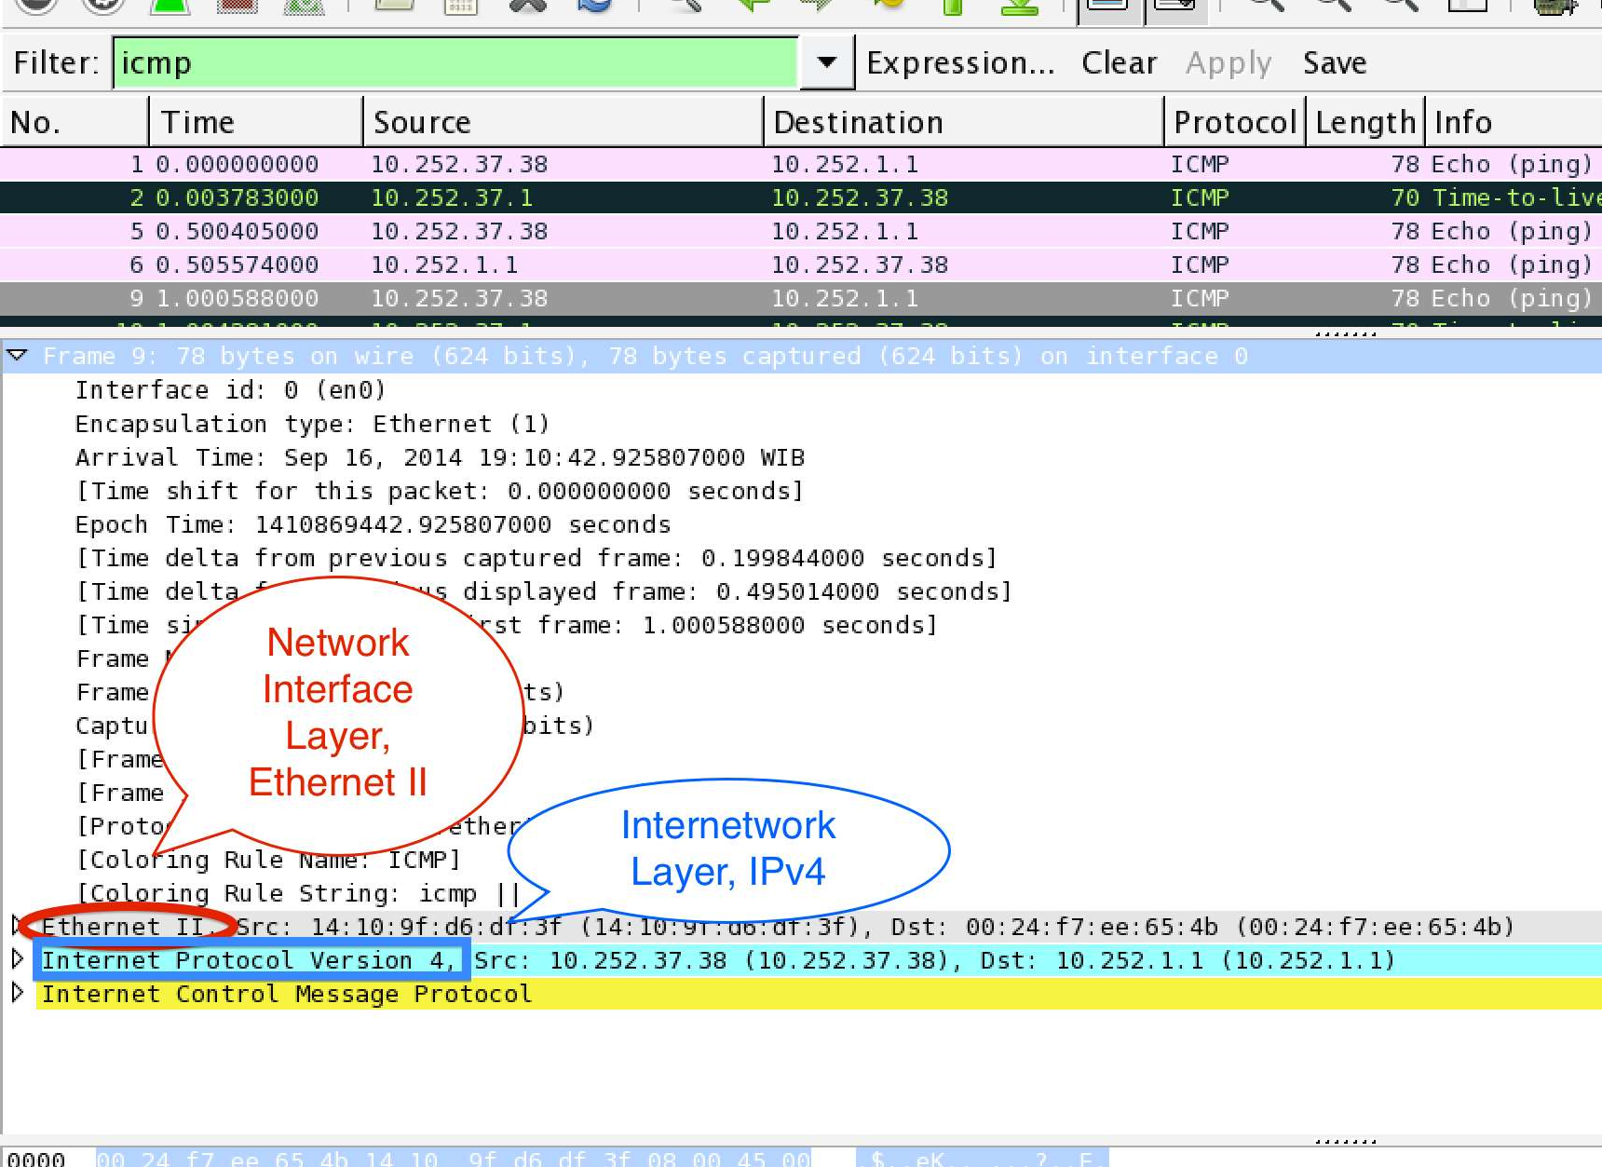

Persiapan Praktikum
- Modul praktikum
- PC yang dilengkapi dengan aplikasi Wireshark
- Jaringan aktif
- Lembar Laporan Praktikum (Lampiran)
- Koneksi LAN dan Internet

Langkah-langkah Praktikum

Menjalankan aplikasi wireshark
- Mahasiswa melakukan pengecekan apakah pada PC yang dipakai sudah terinstall aplikasi wireshark ?!!

- Apabila belum terinstall, mahasiswa harus melakukan installasi di PC yang digunakan !!!

Untuk OS Linux Debian/Ubuntu: dhoto@mypc $ su
root@mypc # apt-get install wireshark

Untuk OSX:
- Download wireshark dan XQuartz
- Lakukan konfigurasi XQuartz pada wireshark

Untuk Windows:
- Download wireshark
- Klik 2x pada installer wireshark

- Klik ikon Wireshark !!!
- Klik pada menu CAPTURE dan memilih INTERFACES.
- Pilih interface yang akan digunakan untuk mengrekam data.
- Klik Start.
- Pada OS linux, jalankan aplikasi TERMINAL dan ketik perintah PING yang digunakan untuk melakukan pengecekan jaringan (tanpa tanda $):
$ ping 10.252.1.1
- Kembali ke aplikasi wireshark, hentikan rekam data dengan cara klik tombol merah pada wireshark. Ambil data untuk jenis tipe: icmp dengan cara memfilter di aplikasi wireshark dan lakukan screen shot pada tampilan wireshark yang kalian gunakan.

Melakukan rekam data untuk jenis protokol tertentu
- Lakukan praktikum seperti kegiatan 2.5.1 dari nomer 4 s/d 8.
- Ganti kegiatan pada no 7, dengan kegiatan berikut:
  - Jalankan aplikasi terminal dan ketik perintah NSLOOKUP yang digunakan untuk mengetahui IP dari suatu tujuan (tanpa tanda $):
$ nslookup www.pens.ac.id Ambil data untuk jenis tipe: dns
  - Jalankan aplikasi web browser dan arahkan ke alamat: ftp://newfs.pens.ac.id
Download salah satu data yang ada di alamat tersebut !!!
Ambil data untuk jenis tipe: ftp
  - Jalankan aplikasi web browser dan arahkan ke alamat: http://www.pens.ac.id
Ambil data untuk jenis tipe: http
- Untuk masing-masing kegiatan diatas, laporkan data yang telah direkam sesuai dengan layer pada TCP/IP model. Gunakan lembar

Laporan praktikum 2. TCP/IP Model. (Lampiran)

Lampiran

Laporan praktikum 2. TCP/IP Model
Kegiatan :
Nama : Muhammad Rafli Zidan Akbari
NRP 5325600033

Data layer
- Application layer
Domain Name System (query)
Transaction ID: 0xe56e
Flags: 0x0100 Standard query
0... .... .... .... = Response: Message is a query
.000 0... .... .... = Opcode: Standard query (0)
.... ..0. .... .... = Truncated: Message is not truncated
.... ...1 .... .... = Recursion desired: Do query recursively
.... .... .0.. .... = Z: reserved (0)
.... .... ...0 .... = Non-authenticated data: Unacceptable
Questions: 1
Answer RRs: 0
Authority RRs: 0
Additional RRs: 0
Queries
p2p-sgp1.discovery.steamserver.net: type A, class IN
Name: p2p-sgp1.discovery.steamserver.net
[Name Length: 34]
[Label Count: 4]
Type: A (1) (Host Address)
Class: IN (0x0001)
[Response In: 127778]
- Host-to-host layer
User Datagram Protocol, Src Port: 56610, Dst Port: 53
Source Port: 56610
Destination Port: 53
Length: 60
Checksum: 0x87a9 [unverified]
[Checksum Status: Unverified]
[Stream index: 2588]
[Stream Packet Number: 23]
[Timestamps]
[Time since first frame: 3 minutes, 47.973467700 seconds]
[Time since previous frame: 16.693987000 seconds]
UDP payload (52 bytes)

- Internetwork layer
Internet Protocol Version 4, Src: 10.252.128.240, Dst: 10.252.128.2
0100 .... = Version: 4
.... 0101 = Header Length: 20 bytes (5)
Differentiated Services Field: 0x00 (DSCP: CS0, ECN: Not-ECT)
0000 00.. = Differentiated Services Codepoint: Default (0)
.... ..00 = Explicit Congestion Notification: Not ECN-Capable Transport (0)
Total Length: 80
Identification: 0x0c4a (3146)
000. .... = Flags: 0x0
0... .... = Reserved bit: Not set
.0.. .... = Don't fragment: Not set
..0. .... = More fragments: Not set
...0 0000 0000 0000 = Fragment Offset: 0
Time to Live: 128
Protocol: UDP (17)
Header Checksum: 0x1769 [validation disabled]
[Header checksum status: Unverified]
Source Address: 10.252.128.240
Destination Address: 10.252.128.2
[Stream index: 137]

- Network Interface layer
Ethernet II, Src: LiteonTechno_e0:b0:35 (24:b2:b9:e0:b0:35), Dst: VMware_9f:5a:c2 (00:50:56:9f:5a:c2)
Destination: VMware_9f:5a:c2 (00:50:56:9f:5a:c2)
.... ..0. .... .... .... .... = LG bit: Globally unique address (factory default)
.... ...0 .... .... .... .... = IG bit: Individual address (unicast)
Source: LiteonTechno_e0:b0:35 (24:b2:b9:e0:b0:35)
.... ..0. .... .... .... .... = LG bit: Globally unique address (factory default)
.... ...0 .... .... .... .... = IG bit: Individual address (unicast)
Type: IPv4 (0x0800)
[Stream index: 122]

Lampiran

Laporan praktikum 2. TCP/IP Model
Kegiatan :
Nama : Muhammad Rafli Zidan Akbari
NRP 5325600033

Data layer
- Application layer
File Transfer Protocol (FTP)
150 Opening ASCII mode data connection for .plex.png (27114 bytes)\r\n
Response code: File status okay; about to open data connection (150)
Response arg: Opening ASCII mode data connection for .plex.png (27114 bytes)
- Host-to-host layer
Transmission Control Protocol, Src Port: 21, Dst Port: 50972, Seq: 462, Ack: 138, Len: 68
Source Port: 21
Destination Port: 50972
[Stream index: 15]
[Stream Packet Number: 26]
[Conversation completeness: Incomplete, DATA (15)]
..0. .... = RST: Absent
...0 .... = FIN: Absent
.... 1... = Data: Present
.... .1.. = ACK: Present
.... ..1. = SYN-ACK: Present
.... ...1 = SYN: Present
[Completeness Flags: ··DASS]
[TCP Segment Len: 68]
Sequence Number: 462 (relative sequence number)
Sequence Number (raw): 1404249539
[Next Sequence Number: 530 (relative sequence number)]
Acknowledgment Number: 138 (relative ack number)
Acknowledgment number (raw): 3655928001
0101 .... = Header Length: 20 bytes (5)
Flags: 0x018 (PSH, ACK)
000. .... .... = Reserved: Not set
...0 .... .... = Accurate ECN: Not set
.... 0... .... = Congestion Window Reduced: Not set
.... .0.. .... = ECN-Echo: Not set
.... ..0. .... = Urgent: Not set
.... ...1 .... = Acknowledgment: Set
.... .... 1... = Push: Set
.... .... .0.. = Reset: Not set
.... .... ..0. = Syn: Not set
.... .... ...0 = Fin: Not set
[TCP Flags: ·······AP···]

Window: 229
[Calculated window size: 29312]
[Window size scaling factor: 128]
Checksum: 0x2a1e [unverified]
[Checksum Status: Unverified]
Urgent Pointer: 0
[Timestamps]
[Time since first frame in this TCP stream: 85.782300 milliseconds]
[Time since previous frame in this TCP stream: 7.033300 milliseconds]
[SEQ/ACK analysis]
[This is an ACK to the segment in frame: 4687]
[The RTT to ACK the segment was: 7.033300 milliseconds]
[iRTT: 10.728000 milliseconds]
[Bytes in flight: 68]
[Bytes sent since last PSH flag: 68]
[Client Contiguous Streams: 1]
[Server Contiguous Streams: 1]
TCP payload (68 bytes)

- Internetwork layer
Internet Protocol Version 4, Src: 202.9.85.80, Dst: 10.252.128.240
0100 .... = Version: 4
.... 0101 = Header Length: 20 bytes (5)
Differentiated Services Field: 0x00 (DSCP: CS0, ECN: Not-ECT)
0000 00.. = Differentiated Services Codepoint: Default (0)
.... ..00 = Explicit Congestion Notification: Not ECN-Capable Transport (0)
Total Length: 108
Identification: 0x7286 (29318)
010. .... = Flags: 0x2, Don't fragment
0... .... = Reserved bit: Not set
.1.. .... = Don't fragment: Set
..0. .... = More fragments: Not set
...0 0000 0000 0000 = Fragment Offset: 0
Time to Live: 63
Protocol: TCP (6)
Header Checksum: 0x1dc0 [validation disabled]
[Header checksum status: Unverified]
Source Address: 202.9.85.80
Destination Address: 10.252.128.240
[Stream index: 327]

- Network Interface layer
Ethernet II, Src: VMware_b5:55:03 (00:50:56:b5:55:03), Dst: LiteonTechno_e0:b0:35 (24:b2:b9:e0:b0:35)
Destination: LiteonTechno_e0:b0:35 (24:b2:b9:e0:b0:35)
.... ..0. .... .... .... .... = LG bit: Globally unique address (factory default)
.... ...0 .... .... .... .... = IG bit: Individual address (unicast)
Source: VMware_b5:55:03 (00:50:56:b5:55:03)
.... ..0. .... .... .... .... = LG bit: Globally unique address (factory default)
.... ...0 .... .... .... .... = IG bit: Individual address (unicast)
Type: IPv4 (0x0800)
[Stream index: 492]

2.6.2 Lampiran

Laporan praktikum 2. TCP/IP Model
Kegiatan :
Nama : Muhammad Rafli Zidan Akbari
NRP 5325600033

Data layer
- Application layer
Hypertext Transfer Protocol
HTTP/1.1 301 Moved Permanently\r\n
Response Version: HTTP/1.1
Status Code: 301
[Status Code Description: Moved Permanently]
Response Phrase: Moved Permanently
Server: nginx\r\n
Date: Tue, 13 Oct 2026 09:31:34 GMT\r\n
Content-Type: text/html\r\n
Content-Length: 162\r\n
[Content length: 162]
Connection: keep-alive\r\n
Location: https://www.pens.ac.id/\r\n
\r\n
[Request in frame: 1331]
[Time since request: 2.878700 milliseconds]
[Request URI: /]
[Full request URI: http://www.pens.ac.id/]
File Data: 162 bytes
- Host-to-host layer
Transmission Control Protocol, Src Port: 80, Dst Port: 52108, Seq: 1, Ack: 79, Len: 353
Source Port: 80
Destination Port: 52108
[Stream index: 5]
[Stream Packet Number: 6]
[Conversation completeness: Complete, WITH_DATA (31)]
..0. .... = RST: Absent
...1 .... = FIN: Present
.... 1... = Data: Present
.... .1.. = ACK: Present
.... ..1. = SYN-ACK: Present
.... ...1 = SYN: Present
[Completeness Flags: ·FDASS]
[TCP Segment Len: 353]
Sequence Number: 1 (relative sequence number)
Sequence Number (raw): 4131522494
[Next Sequence Number: 354 (relative sequence number)]
Acknowledgment Number: 79 (relative ack number)
Acknowledgment number (raw): 2600346201
0101 .... = Header Length: 20 bytes (5)
Flags: 0x018 (PSH, ACK)
000. .... .... = Reserved: Not set
...0 .... .... = Accurate ECN: Not set
.... 0... .... = Congestion Window Reduced: Not set
.... .0.. .... = ECN-Echo: Not set
.... ..0. .... = Urgent: Not set
.... ...1 .... = Acknowledgment: Set
.... .... 1... = Push: Set
.... .... .0.. = Reset: Not set
.... .... ..0. = Syn: Not set
.... .... ...0 = Fin: Not set
[TCP Flags: ·······AP···]
Window: 502
[Calculated window size: 64256]
[Window size scaling factor: 128]
Checksum: 0xc6b5 [unverified]
[Checksum Status: Unverified]
Urgent Pointer: 0
[Timestamps]
[Time since first frame in this TCP stream: 94.456000 milliseconds]
[Time since previous frame in this TCP stream: 1.200 microseconds]
[SEQ/ACK analysis]
[iRTT: 87.654800 milliseconds]
[Bytes in flight: 353]
[Bytes sent since last PSH flag: 353]
[Client Contiguous Streams: 1]
[Server Contiguous Streams: 1]
TCP payload (353 bytes)

- Internetwork layer
Internet Protocol Version 4, Src: 202.9.85.176, Dst: 10.252.128.240
0100 .... = Version: 4
.... 0101 = Header Length: 20 bytes (5)
Differentiated Services Field: 0x00 (DSCP: CS0, ECN: Not-ECT)
0000 00.. = Differentiated Services Codepoint: Default (0)
.... ..00 = Explicit Congestion Notification: Not ECN-Capable Transport (0)
Total Length: 393
Identification: 0xfb6d (64365)
010. .... = Flags: 0x2, Don't fragment
0... .... = Reserved bit: Not set
.1.. .... = Don't fragment: Set
..0. .... = More fragments: Not set
...0 0000 0000 0000 = Fragment Offset: 0
Time to Live: 63
Protocol: TCP (6)
Header Checksum: 0x935b [validation disabled]
[Header checksum status: Unverified]
Source Address: 202.9.85.176
Destination Address: 10.252.128.240
[Stream index: 144]

- Network Interface layer
Ethernet II, Src: VMware_b5:55:03 (00:50:56:b5:55:03), Dst: LiteonTechno_e0:b0:35 (24:b2:b9:e0:b0:35)
Destination: LiteonTechno_e0:b0:35 (24:b2:b9:e0:b0:35)
.... ..0. .... .... .... .... = LG bit: Globally unique address (factory default)
.... ...0 .... .... .... .... = IG bit: Individual address (unicast)
Source: VMware_b5:55:03 (00:50:56:b5:55:03)
.... ..0. .... .... .... .... = LG bit: Globally unique address (factory default)
.... ...0 .... .... .... .... = IG bit: Individual address (unicast)
Type: IPv4 (0x0800)
[Stream index: 226]

== http://lecturer.pens.ac.id/~dhoto ==

